2026 Critical Care Update

June 18, 2026

Park City Hospital

SPEAKER & PLANNING COMMITTEE DISCLOSURE

Disclosure of Financial Relationships and Resolution of Conflicts of Interest

The Accreditation Council for Continuing Medical Education (ACCME) and American Nurses Credentialing Center’s Commission on Accreditation (ANCC) standards and guidelines require that individuals participating in CE activities are aware of commercial interests that could potentially affect the education presented. Intermountain Health adheres to ACCME and ANCC Standards regarding industry support of continuing education and disclosure of faculty and commercial sponsor relationships (if any) will be made known below.

Target Audience - Physician, Advanced Practice Provider, Health Professional, Nurse, Nurse Practitioner, Nurse-Clinical, Pharmacist, Respiratory Therapist, Physician Assistant

Planner and Faculty Disclosures:
It is policy at Intermountain Health’s Interprofessional Continuing Education Department for individuals who are in a position to control the content of an educational activity to disclose to the learners all relevant financial relationships that they have with any commercial interest that provide products or services that may be relevant to the content of this continuing education activity.

Below is a list of all planners and faculty and the nature of their disclosed financial relationships:
Name of individual | Individual's role in activity | Nature of Relationship(s) / Name of Ineligible Company(s)
Amy Cacace, MD | Faculty | Nothing to disclose - 05/16/2026
Andy R. Badke, MD | Faculty | Nothing to disclose - 04/14/2026
Carrie M. Winberg, MSHA | Other Planning Committee Member | Nothing to disclose - 04/22/2026
Christopher B. Jones, MHA, BSN, RN | Nurse Planner | Nothing to disclose - 04/29/2026
Colin K. Grissom, MD | Course Director, Faculty | Grant or research support-GEn1E Lifesciences - 05/07/2026
Elizabeth Munroe, MD | Faculty | Nothing to disclose - 04/24/2026
Gabe V Fontaine, PharmD, MBA, BCCCP, BCPS, FNCS, FCCM | Other Planning Committee Member | Speakers Bureau-Chiesi|Speakers Bureau-Alexion|Advisor-Chiesi|Advisor-Bayer|Advisor-Grifols (Relationship has ended)|Advisor-Annexon (Relationship has ended)|Advisor-SERB|Membership on Advisory Committees or Review Panels, Board Membership, etc.-Anticoagulation Forum - 04/16/2026
John Skaggs, MD | Faculty | Nothing to disclose - 04/27/2026
Kevin Meier, MD | Faculty | Nothing to disclose - 06/01/2026
Kristi Kulasa, MD | Faculty | Nothing to disclose - 11/25/2025
Lindsay M. Leither, DO | Faculty | Nothing to disclose - 04/20/2026
Lora A Brown, AS, CAP | Other Planning Committee Member | Nothing to disclose - 04/22/2026

All relevant financial relationships have been mitigated.

ACCREDITATION

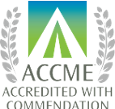

Intermountain Health is accredited by the Accreditation Council for Continuing Medical Education (ACCME) to provide continuing medical education for physicians.

AMA Credit
Intermountain Health designates this live activity for a maximum of 6.50 AMA PRA Category 1 Credit(s).™ Physicians should claim only the credit commensurate with the extent of their participation in the activity.

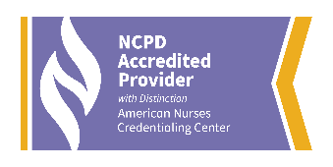
Nursing Accreditation
Intermountain Health is accredited as a provider of nursing continuing professional development by the American Nurses Credentialing Center's Commission on Accreditation. This live activity offers a maximum of 6.50 nursing contact hours. Successful completion is attendance at the entire event.
 American Board of Internal Medicine’s (ABIM) Maintenance of Certification (MOC)
Successful completion of this CME activity, which includes participation in the evaluation component, enables the participant to earn up to 6.5* MOC points in the American Board of Internal Medicine’s (ABIM) Maintenance of Certification (MOC) program. Participants will earn MOC points equivalent to the amount of CME credits claimed for the activity. It is the CME activity provider’s responsibility to submit participant completion information to ACCME for the purpose of granting ABIM MOC credit.
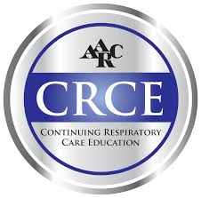 Continuing Respiratory Care Education
This program has been approved for a maximum of 6.50 contact hour(s) Continuing Respiratory Care Education (CRCE) credit by the American Association for Respiratory Care, 9425 N. MacArthur Blvd. Suite 100 Irving, TX 75063. Course #196341000



*Credit hours are subject to change and are based on actual learning hours and at the discretion of IPCE.

